Adrenal Surgery for Patients Endocrine Surgery Tygerberg Hospital
By Ilna Conradie and Rooi Sello with reference to BAETS patient information leaflets
About Tygerberg Hospital Endocrine Surgery:
You will be managed by a TEAM of doctors. Each member of the team has a very specific role, and we need the whole team in order to offer you the best adrenal care.
Tygerberg Hospital is an academic hospital, so there are different levels of specialists you will encounter within the team. The advantage is that you will have a lot of thought and discussion around your case, and you might even learn something when we do our academic rounds!
Endocrine surgeons, endocrinologists and anaesthetists focus specifically on your type of disease. We will try and explain more about your disease process and why we are recommending surgery:
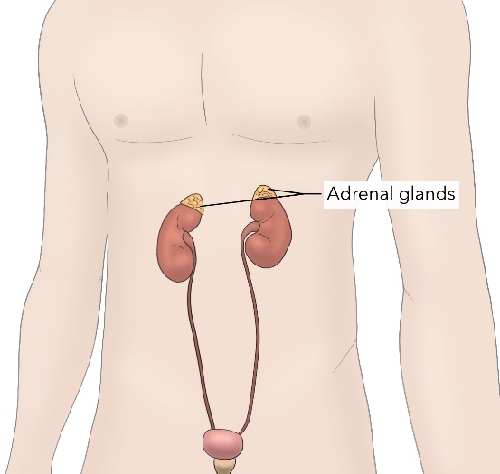
What are the adrenal glands?
The adrenal gland is a small organ that lies just above your kidney. It makes hormones that regulates your body’s function.
The hormones are secreted by the different layers in the adrenal gland. The most important hormones are:
- Adrenalin: responsible for the ‘fight or flight’’ response
- Cortisol: one of the stress hormones, but also important in sugar metabolism
- Aldosterone: regulates your body’s salt levels as well as blood pressure
- Androgens (sex hormones): the adrenal gland makes a small contribution toward your body’s sex hormones

When is it abnormal?
There can be enlargement of the adrenal gland WITHOUT excessive hormone release, and this we describe as a ‘’non-functional’’ tumor. If a tumor develops from the hormone producing cells in one of the layers of the gland, it may also overproduce one of the hormones, or a combination of these hormones – termed a ‘’functional’’ tumor.

The most common functional diagnoses you will hear the doctors talk about, is:
- Pheochromocytoma (producing adrenalin)
- Cushing’s syndrome (producing cortisol)
- Conn’s syndrome (producing aldosterone)
When is surgery of the adrenal gland recommended?
Tumors are commonly seen in the adrenal gland, and most of the time this is benign (‘’non-cancerous’’) and do not need any treatment. Most commonly surgery is indicated to:
- Remove the cause of hormone release and bring your body back into balance (for ‘’functional’’ tumors)
- Remove a mass that might be a cancer: in most cases it is not advised to biopsy the adrenal gland because of the risk of cancerous spread through the biopsy tract. If it is not clear on the CT scan if the tumor has a risk of spreading to other organs in the body, we might recommend removal. The pathologist will then look at the tumor with a microscope and see if there is cancer. The aim of this operation will therefor be DIAGNOSIS.
- Remove a single metastatic lesion to the adrenal gland. This is sometimes seen when there is a cancer elsewhere in the body, and the only spread is in the adrenal gland.
Types of adrenal operations done at Tygerberg Hospital:
- Open surgery: this is the traditional type of surgery which involves cutting of skin and tissues so that the surgeon has a full view of the structures or organs involved.
- Laparoscopic surgery: it is the same operation on the inside, but instead of a large incision, we make 3-4 small 1cm incision, and then do the work on the inside with a camera (laparoscope) and long instruments.
- Retroperitoneoscopic surgery: This operation is also with the laparoscope, but from the back. It allows for a quicker operation with less post-operative pain, but not all cases are ideal for this approach.

Your surgeon will recommend the best operation suitable for your specific case. There are specific reasons why we would recommend one or the other surgery and it depends on patient to patient which surgery will be most appropriate.

